Present by Nazia Siraj

GICIC 00443199

Friday 9am-12pm

Mentor Sir Humza Syed

DAY 4 – BUILDING DYNAMIC FRONTEND COMPONENTS FOR YOUR MARKETPLACE

### **1. Sanity Check**

### The data retrieved from the API undergoes a **sanity check** to validate its accuracy, consistency, and completeness.

### This check ensures the data is correct and free from errors.

### **2. Data Processing**

### After the sanity check, the data is **successfully processed**.

### The data is parsed, ensuring it fits the required format or structure.

### **3. Display in Application**

### The validated and processed data is **now displayed** in the application or system.

### It is ready for presentation, ensuring no issues or errors during display.

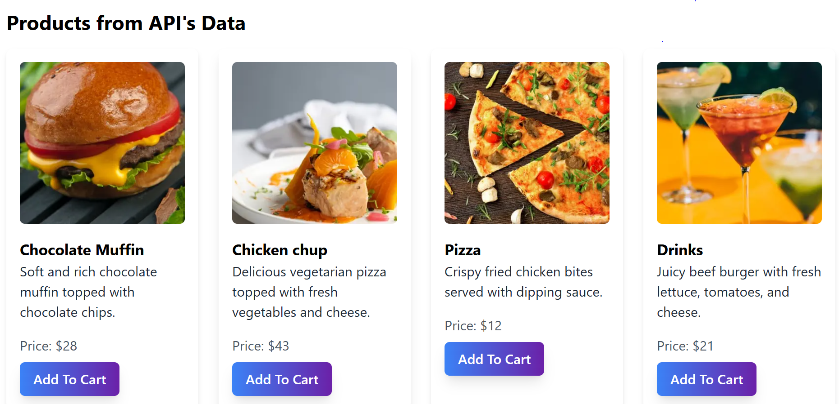

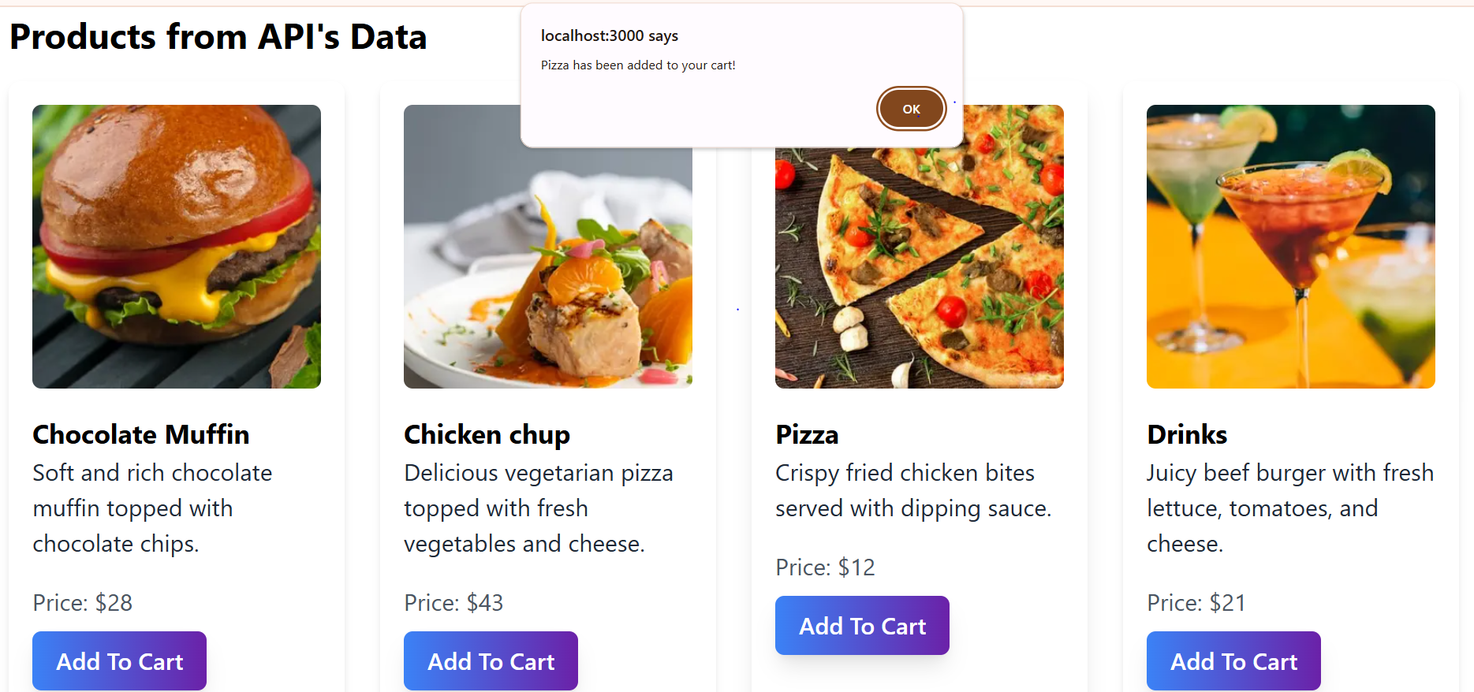

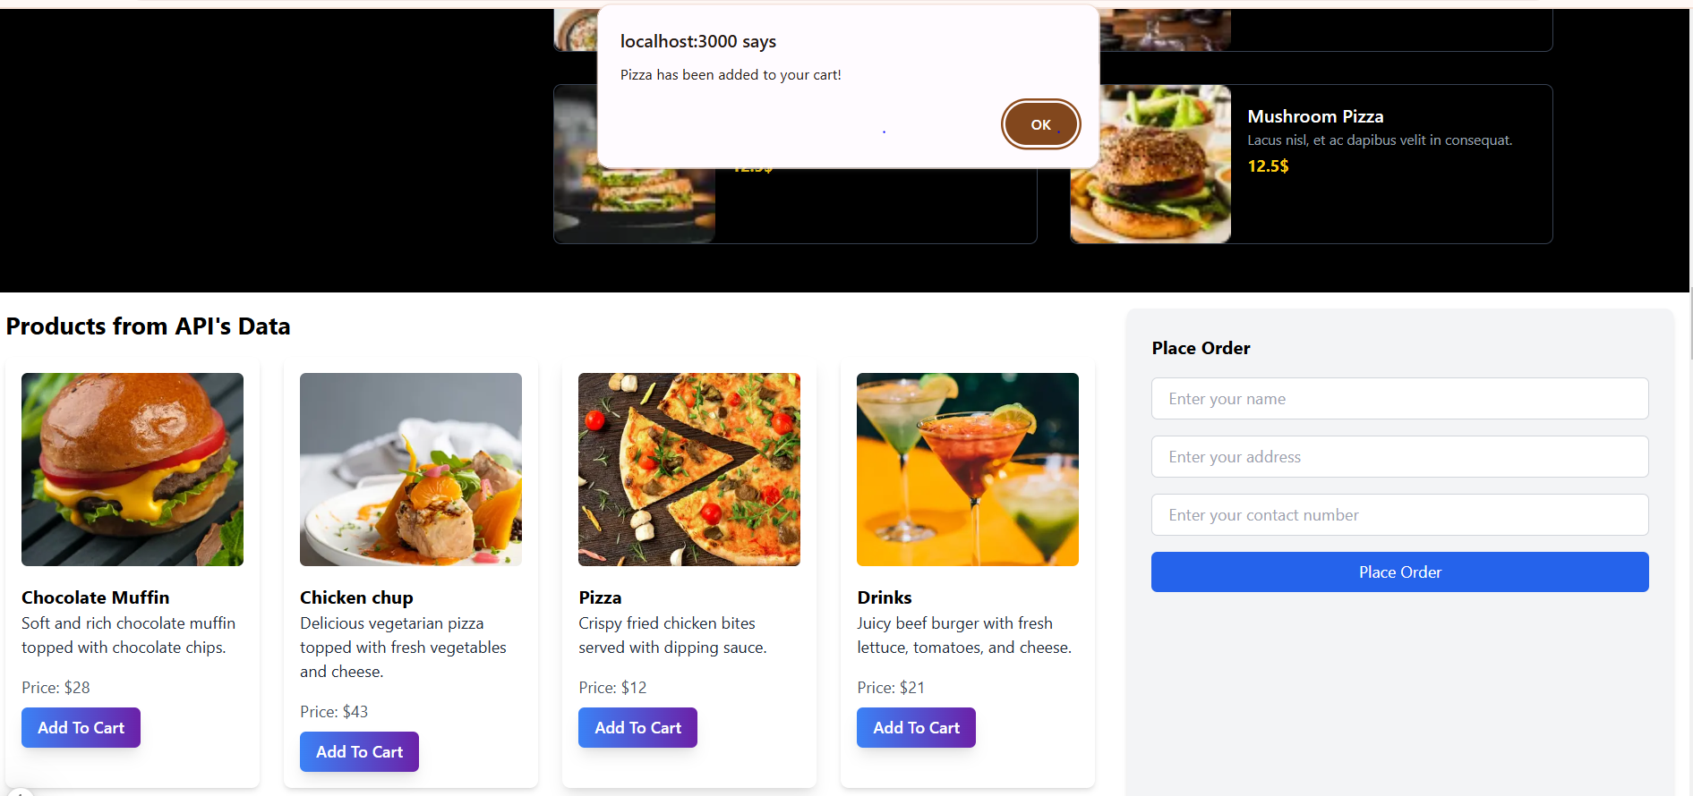

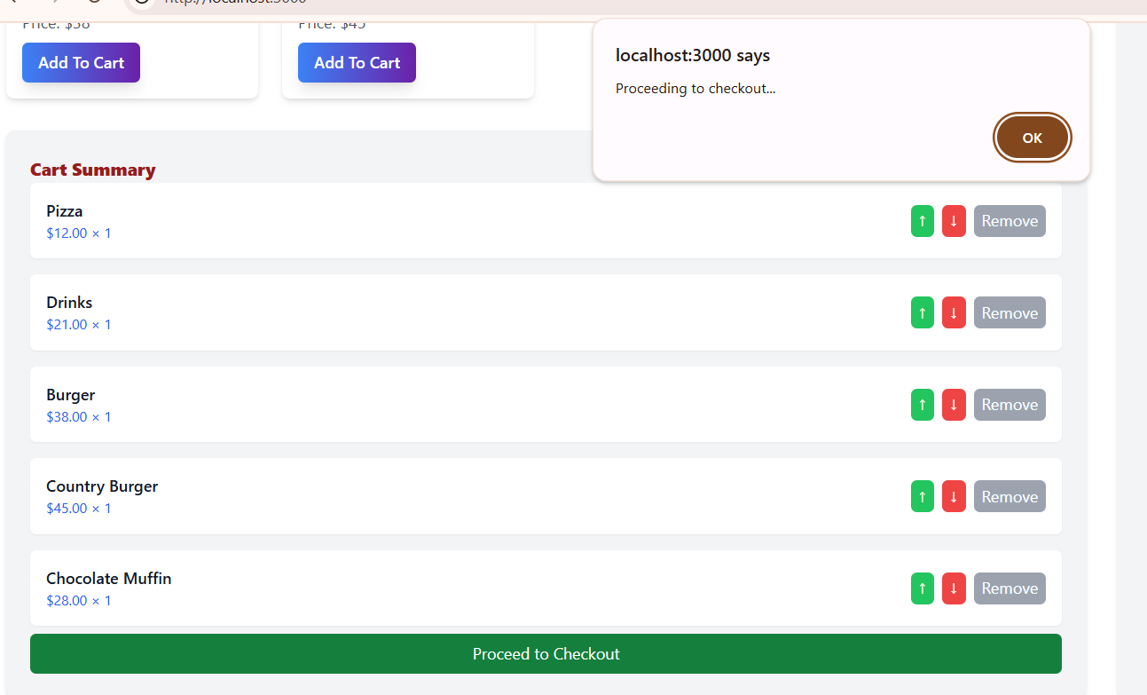

**1. Data Fetching and Sanity Check**

The data is successfully fetched through the API and validated through a comprehensive sanity check, ensuring that it is accurate, complete, and free from any errors.

**2. Add to Cart Functionality**

The "Add to Cart" feature has been implemented, allowing users to easily add selected items to their shopping cart with smooth integration and no issues.

**3. Place Order Feature**

Once items are added to the cart, the "Place Order" functionality allows users to proceed with their selections and confirm their order details without any obstacles.

**4. Checkout Process**

The checkout process is fully functional, enabling users to review their order, provide necessary shipping details, and complete the purchase seamlessly, ensuring a hassle-free transaction experience.

**5. Overall Performance**

All features, from data retrieval through the API to order finalization, are performing successfully and delivering a smooth, user-friendly experience.

**1. Dynamic Product Display**

All products are now dynamically displayed on the platform. When users interact with the product listings, they can see the entire product catalog seamlessly load based on real-time data, ensuring an up-to-date and relevant selection.

**2. Click-to-View Product Details**

Upon clicking a product, users are directed to the product’s detailed view. This feature allows users to explore each product's specifications, images, prices, and availability, offering a personalized browsing experience.

**3. Smooth Navigation**

The process of opening products dynamically ensures smooth navigation, as the interface quickly responds to user clicks, providing instant access to product details without any delays.

**4. Real-Time Data Integration**

Product information, from prices to descriptions, is fetched dynamically, ensuring that any updates in the inventory or product data are reflected immediately, keeping users informed of the latest offerings.

5. User-Friendly Experience

With the dynamic opening of products and click-to-view functionality, the platform ensures an engaging, efficient, and interactive shopping experience for users.

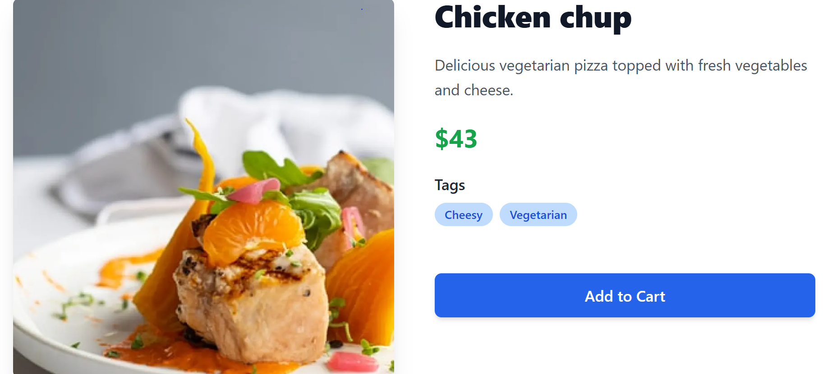

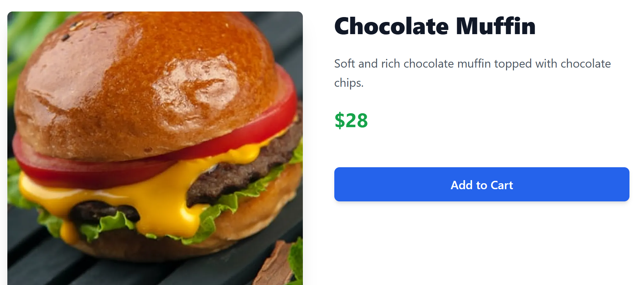

OVERVIEW

On Day 4, the focus was on building dynamic frontend components for the Food Truck Restaurant website. These components aim to provide a seamless user experience, ensuring that customers can easily explore and order food items through the platform. The goal was to design and implement reusable, responsive, and modular components that dynamically display product and restaurant data fetched from Sanity CMS. By doing so, users can interact smoothly with the website. The project implements the following functionalities:

**1. Food Listing Page**

**2. Food Detail Component**

**3. Restaurant Categories Component**

**4. Search Bar for Dishes and Restaurants**

**5. Cart Component**

**6. Wishlist Component**

**7. Checkout Component**

**8. User Profile Component**

**9. Pagination Component for Menus**

**10. Footer and Header Components**

**11. Customer Reviews and Ratings Component**

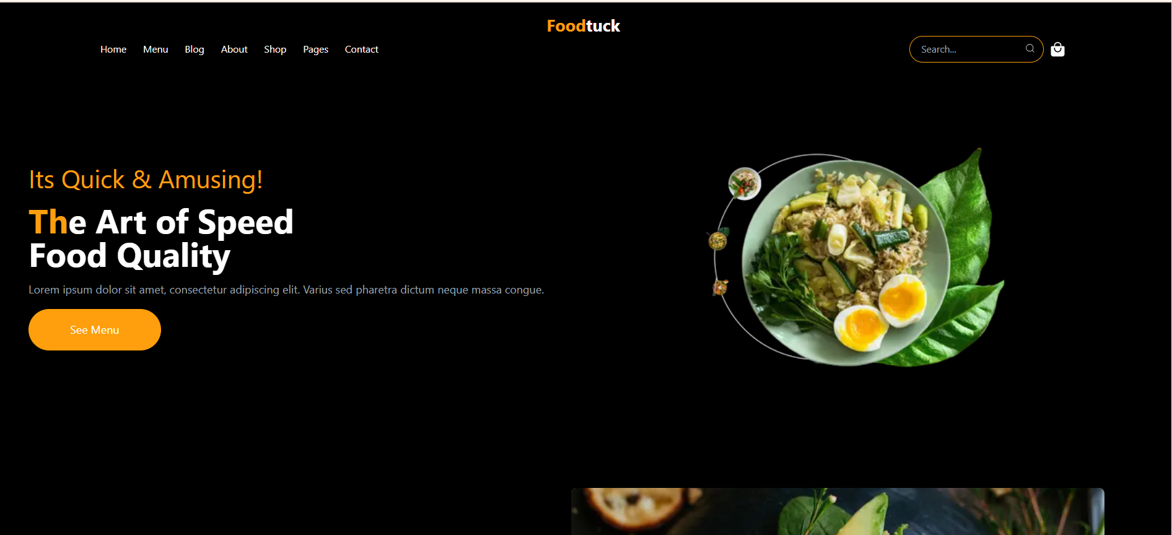

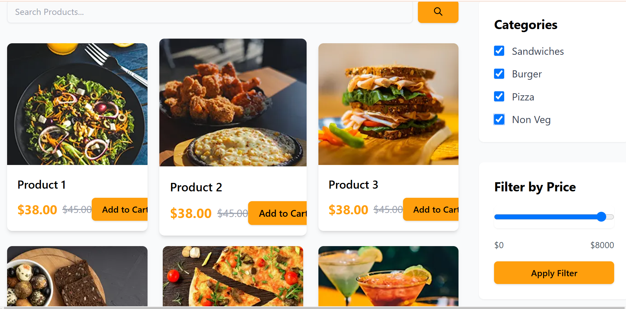

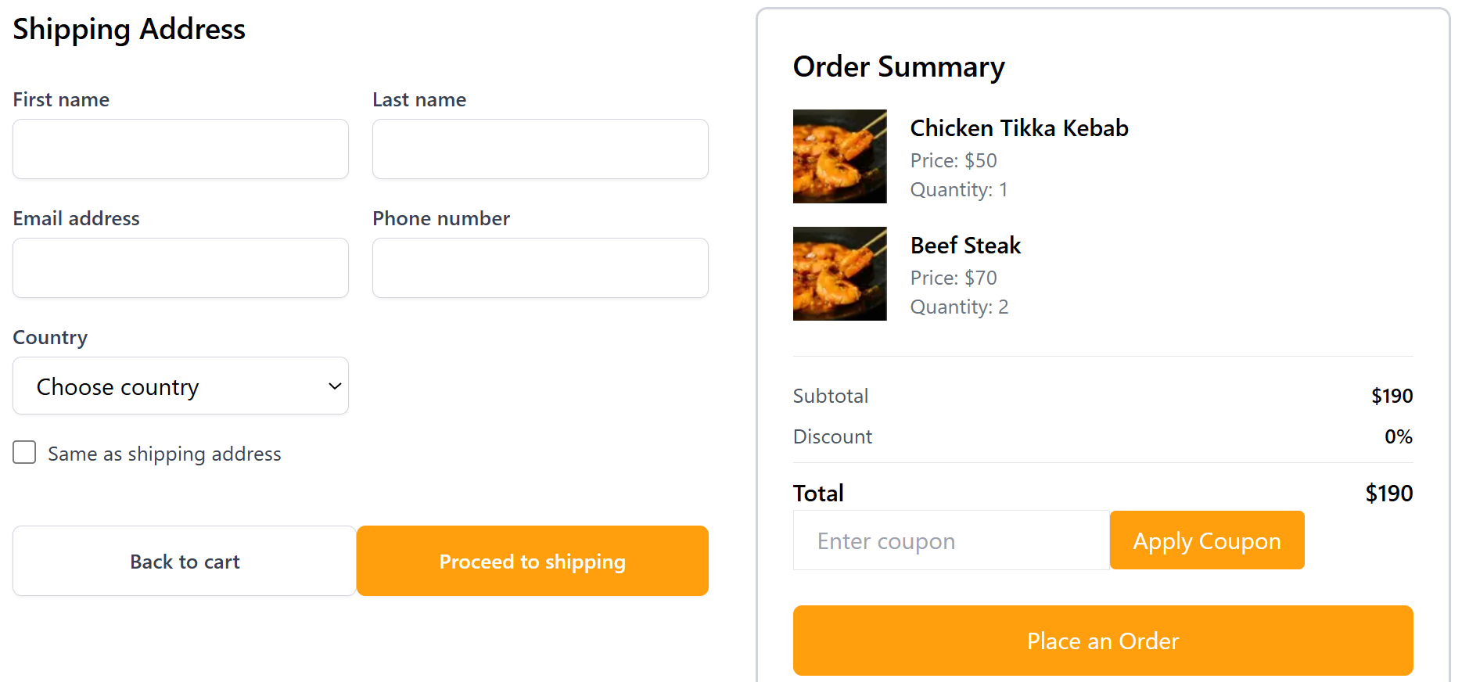

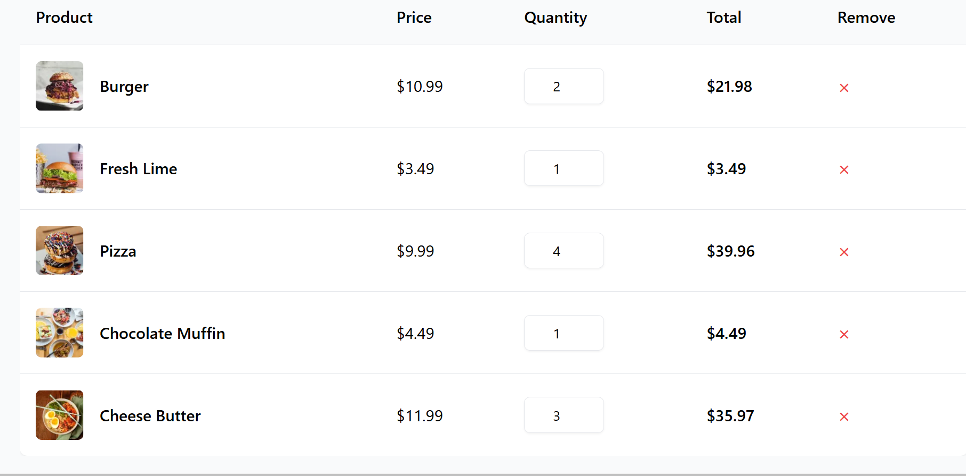

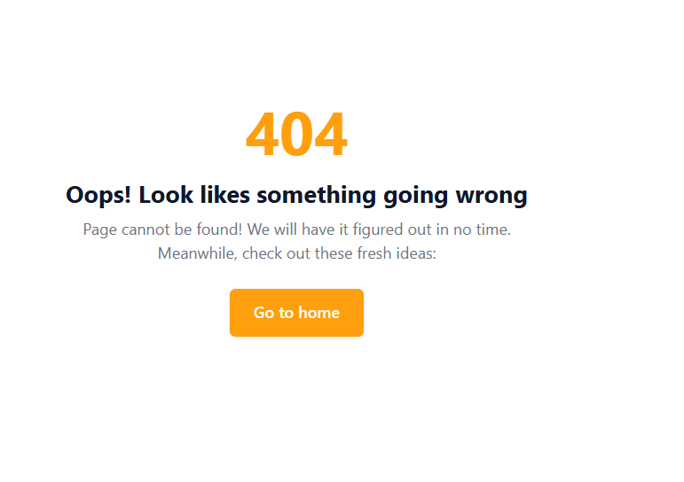

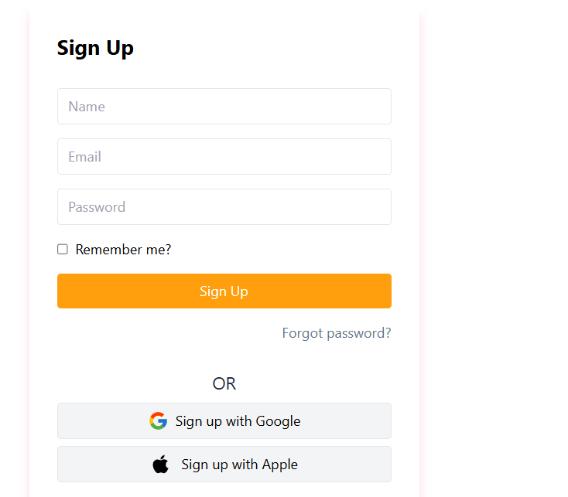

**1.Product Listing Component**

The Product Listing Page serves as the primary interface for users to explore a wide range of products presented in an organized and visually appealing grid layout. This component ensures a seamless user experience, blending functionality and design to deliver dynamic and up-to-date product information.

**Key Features:**

* **Real-Time Data Integration:**

Product data is fetched live from Sanity CMS, ensuring that users always view the latest updates, such as new arrivals, price changes, or stock availability.

* **Structured Grid Layout:**

The grid layout offers a clean, organized view of products, making it easier for users to browse and interact. This design enhances user engagement by providing a clear and consistent interface.

* **Fully Responsive Design:**

The layout adapts seamlessly to different screen sizes and devices, offering an optimal experience on smartphones, tablets, and desktops.

* **Interactive Product Cards:**

Each product card provides the essential details users need at a glance, including:

Product Image – High-quality visuals to attract attention.

Product Name – Clear and concise titles for easy identification.

Price – Displayed prominently for quick decision-making.

Category – Organized grouping for intuitive browsing.

Status – Availability updates (e.g., "Available" or "Not A vailable").

* **Benefits for Users:**

Effortless navigation through a well-structured interface.

A visually appealing and functional layout that works flawlessly across all devices.

Real-time updates ensure product information is always accurate and reliable.

2.Product Detail Component

The Product Detail Page offers an immersive and user-friendly experience, presenting each product's data dynamically. Leveraging Next.js dynamic routing, every product has a uniquely tailored page, enabling users to easily explore and understand specific product details in a highly interactive way.

**Dynamic Routing for Seamless Navigation**

Each product’s page is dynamically routed via Product/[slug]/page.tsx.

The slug serves as a unique identifier, allowing URLs like /product/abc123 to fetch and render product-specific data effortlessly.

**Dynamic Data Fetching**

Real-time data fetching ensures up-to-date product details are displayed without delays.

Users can instantly access all relevant product information dynamically rendered based on the URL.

**Modern and Clean UI Design**

The UI is visually appealing, structured with a focus on clarity and readability:

**Intuitive Layout**: Ensures quick access to key product details.

**Responsive Design:** Optimized for various devices, offering a seamless experience across mobile, tablet, and desktop screens.

**Interactive Features:** Includes hover effects, dropdowns for color/size selection, and smooth image sliders to enhance user engagement.

**Comprehensive Product Information**

The page provides all critical product details, displayed systematically for easy navigation:

**Product Name**

**Product Images:** Includes an image carousel with zoom functionality for detailed views.

**Price**: Showcases price with discounts (if applicable).

**Description**: A rich, visually formatted text area for detailed descriptions.

**Inventory & Status:** Clear stock information, including "In Stock" or "Out of Stock" labels.

**Category**: Helps users quickly identify product categories.

**Visual Enhancements**

Use of high-resolution product images.

Strategic use of whitespace to maintain a clean, distraction-free appearance.

Highlighted call-to-action buttons like “Add to Cart” and “Buy Now” for ease of purchasing.

3. Search Bar

The Search bar Components allows users to easily search for products by trying the products name .This component provides an efficient way for users to find specific products from a large catalog. As the user types in the search fields, it dynamically filters and displays matching results in real-time.

4.Cart Components

The Cart Page allows users to view and manage the items they have added to their cart. When a user clicks on the Add to cart button for a selected product, the product is stored in the cart ,allowing users to review and modify their selections before proceeding to checkout .uUsers can easily adjust the quantity of each item or remove products they no longer wish to purchase. The cart page also typically includes buttons for proceeding to checkout or continuing shopping, offering clear paths for users to finalize their purchase or keep browsing



5.Wishlist Components

The wishlist components allow users to save their favourite products for future reference.When a user comes across a product they like but are not ready to purchase immediately, they can add it to their wish list with a simple click. This feature enables users to personalize a list of products they are interested in, making it easier for them to revisit and purchase later.The wish list displays their saved items along with essential product details.Users can also remove items from them if they no longer wish to save them.



6.Checkout Flow Components

* The Checkout Flow Component is a multi-step form designed to guide users through the checkout process, ensuring that all necessary information is collected before completing their purchase.

**Review Cart Items**

* Users see a summary of the items they’ve selected, including product name, quantity, and price, and can make any changes.

**User and Payment Detail**

* In this step, users select a payment method among (Easy Paisa, Jazz Cash, On Cash Delivery, Credit, or Debit Card). Users enter their payment information. Along with payment details, users also need to provide personal details such as their username, email address, and billing address.

**Place Order**

* Users review all details and click place order to complete the purchase.

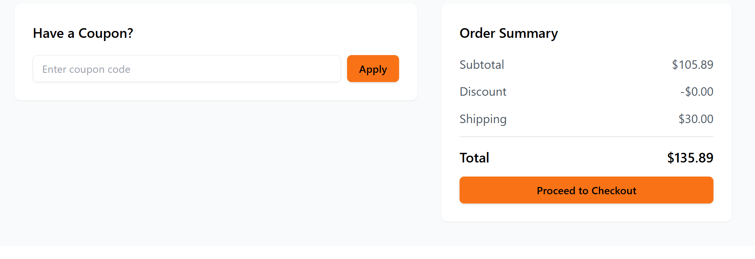



7.Footer & Header Components

* The Header and Footer components are essential for the website, providing an easily accessible navigation structure across all pages. These both appear on all pages through the layout system.
* The Header is sticky at the top of the page which includes links to important pages like Home, Shop, About, Contact, and Cart, along with a search bar and user account/login options. The company logo is also displayed in the header.
* The Footer appears at the bottom of each page, providing links to Privacy Policy, Terms & Conditions, FAQs, and Social Media along with contact details.
* Both components are designed to be responsive, adapting to different screen sizes. This allows users to easily navigate and access key information across the site, whether on mobile or desktop.

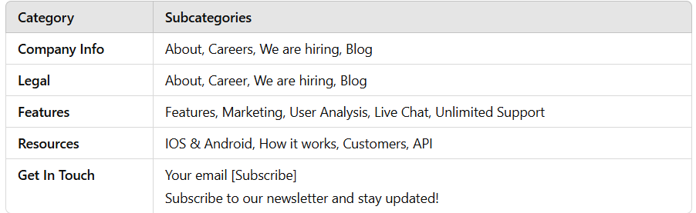

|  |  |
| --- | --- |
|  |  |
|  |  |
|  |  |
|  |  |
|  |  |
|  |  |
|  |  |
|  |  |
|  |  |

8.Technical Reports

**Steps Taken to Build and Integrate Components**

* Created a Next.js project and set up Sanity CMS for managing products.
* Integrated external API to migrate data into Sanity CMS.
* Fetched data from Sanity CMS for product listing and individual product pages.
* Data fetched from Sanity CMS via API calls.
* Used a dynamic grid layout to display products.

|  |  |  |  |  |  |  |  |
| --- | --- | --- | --- | --- | --- | --- | --- |
| **Test Case ID** | **Test Case Description** | **Test Steps** | **Expected Result** | **Actual Result** | **Status** | **Severity Level** | **Remarks** |
| TC001 | Product Listing - Image Fetch Failure | 1. Go to product listing. 2. Simulate network issue. | Product images should load correctly | Error message "Image fetch failed" appeared due to network issue. | Failed | Medium | Fixed by resolving the network issue. |
| TC002 | Checkout Process with Missing Cart Items | 1. Attempt to checkout with no items in the cart. 2. Verify error message. | A message should appear saying "Your cart is empty." | "Cart is empty" message appeared correctly. | Passed | Low | Checkout functionality worked as expected. |
| TC003 | Product Search Functionality | Enter a search term. Verify search results are relevant. | Relevant products related to search should appear. | Relevant results appeared for the search. | Passed | Medium | Search works correctly. |
| TC004 | Error Handling for API Failure | Disconnect internet or simulate API failure. | Error message should appear. | Error message displayed as expected. | Passed | High | Error handling works successfully. |
| TC005 | Mobile Responsiveness | Verify that the product layout adapts correctly to all screen sizes. | Layout should be responsive across all devices. | Layout was responsive on all screen sizes, no issues. | Passed | Low | Mobile version tested successfully. |
| TC006 | Security - Input Validation for Email Field | Enter an invalid email address. | Form should reject invalid email formats with an error. | Invalid email was rejected with an error. | Passed | High | Email validation works as expected. |
| TC007 | User Login with Incorrect Credentials | 1. Enter incorrect username/password. | User should see an error message "Invalid username or password." | Error message displayed correctly. | Passed | Medium | Handled successfully as expected. |

* Implemented Features
* Implemented dynamic routing in Next.js to show individual product details.
* Added functionality for users to search products by product name.
* Implemented state management for adding items to the cart and wish list.
* Created a multi-step checkout form for users to enter billing, shipping details, and payment information.
* Created a cart page to show products added in the cart by users.
* Created a wish list to show products added in the wish list by users.
* Used Tailwind CSS for styling, ensuring the application is responsive and works on both mobile and desktop devices.

**Challenges Faced and Solutions Implemented**

* Initially, I faced issues with fetching data from Sanity CMS.

SOLUTION: I double-checked the API keys, tested queries in Sanity Studio, and also tested the APIs in Postman. I compared the external API product schema with the Sanity schema to ensure they were the same.

* Struggled with dynamically displaying product details.

SOLUTION: Used Next.js dynamic routing (/product/[slug]) to handle individual product pages and render the product data dynamically based on the URL.

* Managing the cart and wishlist states across components was complex.

SOLUTION: Used React’s useState for local state management.

---

**✔ Best Practices Followed During Development**

* Built reusable components like ProductCard and ProductDetail to maintain clean and organized code.
* Used useState to efficiently manage application state.
* Followed mobile-first design principles using Tailwind CSS for styling, ensuring the app is fully responsive across all devices.

**Self-Validation Checklist for Day 4**

✅ 1. Product Listing Component

✅ 2. Product Detail Component

✅ 3. Category Component

✅ 4. Cart Component

✅ 5. Wishlist Component

✅ 6. User Profile Component

✅ 7. Review Ratings Component

✅ 8. Related Products Component

✅ 9. Header Component

✅ 10. Footer Component

✅ 11. Styling and Responsiveness

✅ 12. Code Quality

📄 Documentation and Submission ✅

**Conclusion:**

On Day 4, students gained valuable experience in building dynamic frontend components using real-time data fetched from Sanity CMS or APIs. The focus on modularity, state management, and responsive design ensured that the components were scalable and production-ready. By following best practices, students are now equipped to build dynamic and interactive web applications suitable for real-world projects.